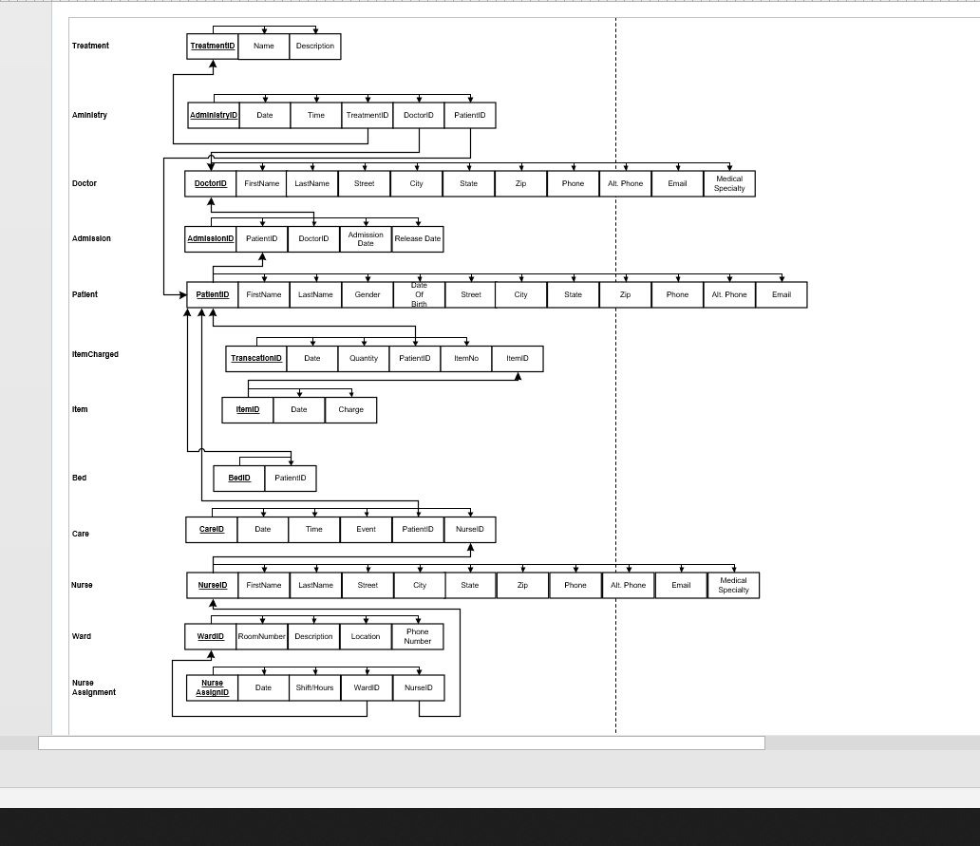**Hospital Database Design Document**

**Version 1.1**

**Submittal Date: 09/08/2021**

|  |  |
| --- | --- |
| Version | Description |
| 1.0  1.1 | First release draft  Added Relation Schema |

**Table of Contents**

**Topic Page**

**Purpose…………………………………………………………………………………………4**

**Narrative……………………………………………………………………………………….4**

**Requirements (Actors/Roles)………………………………………………………………….6**

**Entities………………………………………………………………………………………….6**

**Entities(w/ Nested Attributes)………………………………………………………………7-8**

**Business Rules…………………………………………………………………………………..9**

**ERD……………………………………………………………………………………………..10**

**EERD……………………………………………………………………………………………11**

**Purpose**

The purpose of this Database Design Document (DBDD) is to Oversee the majority of the functions that occur in a hospital

**Narrative**

The hospital administrator wants to create a database to track nurse assignments to their wards and nurse interactions with their patients, patient admissions by their doctors and treatments administered by doctors to their patients, bed assignments for each patient and items charged to patients during their stay. Administrator wants to record each nurse’s name and address, phone and alternate phone, email and the medical specialties he or she is certified. Some nurses supervise one or more other nurses. No nurse is supervised by more than one nurse, and some nurses are unsupervised.

Each ward at the hospital has a designated number, descriptive name, physical location and phone number. Each ward has at least one nurse assigned to it. A nurse is assigned to at least one ward and rotates assignments among other wards. The assignment is tracked by the specific date and the hours worked in the assigned ward by each nurse on that date.

In addition to nurse assignments, each ward also has a charge nurse. The charge nurse is the custodian of the medical records for the ward. Not all nurses act in this capacity, but those that do are in charge of only one ward, and a ward only has one charge nurse.

A ward consists of hospital beds. The beds are inventoried to a specific ward. Information on beds including their size (small, large, extra-large) and their type (elevated electrically or manually). Most of the beds are large and manual (this is the default setting).

When a patient is admitted to the hospital they are assigned to a specific bed. Not all beds are available for use all the time, and a bed may not be assigned to more than one patient.

Information on patients is recorded: name, gender, dob, address, phone, alternate phone, email.

The date the patient is admitted to the hospital, the admitting doctor, the date the patient is discharged, and discharging doctor are also tracked.

Some doctors admit patients while others do not. Doctor information tracked: name, address, phone, alternate phone, email, and their medical specialties.

The hospital tracks the treatments administered to patients and the treating doctor. Treat­ments are tracked by name, description, and charge. The hospital also tracks the date and time of each treatment administered and the results. Some doctors treat patients while others do not.

A given patient may receive no treatments or may receive many, and some patients may receive their treatments from more than one doctor. Some treatments have yet to be used while others have been used often.

In addition to treatments, patients incur other charges for items used during their stay. The hospital tracks these charges as “items” and stores information on what items have been charged to which patients, based on date and quantity. Information that is to be stored for each item includes the item name and charge. All patients incur at least one charge for consumable items used during their stay. Some items are used often while items may be new or unusual in nature and might rarely or never be charged to any patients.

Lastly, the hospital tracks nurse patient care. Each nurse patient care interaction is an event. There are several types of events: wellness check, medication, food service, assistance, treatment admin, and “other.” Given the number of shifts and ward rotations, a patient will typically be seen by more than one nurse during their stay, and a nurse most likely will interact with the same patient over several events during a single shift.

**Requirements (Actors and Roles)**

**Nurse –** The Nurse is the one that is taking care of the patient. A nurse can also be in charge of a ward.

**Ward –** The Ward is the facility in which hospital beds are kept . Patients are assigned to beds which are from a ward.

**Doctor-** The Doctor is the one that admits patients and administers treatment if needed .

**Patient-** The Patient is the one that comes into the hospital , A patient can also be given in there stay that can be charged. Patients will always be assigned a bed

**Bed-** Is the entity that patients get assigned to upon admittance into the hospital , A patient cannot have more than 1 bed

**Treatment-** Treatment is what the Doctor administers to the patient(s)

**Item-** Is something that the patient is charged when staying with the hospital . this could be clothes to food etc.

**Entities**

* **Nurse**
* **Ward**
* **Doctor**
* **Patient**
* **Bed**
* **Treatment**
* **Item**

**Entities w/Nested Attributes**

* **Nurse**
  + **NurseID**
  + Name
  + Address
  + Phone Number
  + Alternate Phone Number
  + Email
  + Medical Specialties
* **Ward**
* **WardID**
* RoomNumber
* Description
* Location
* Phone Number
* **Patient**
* **PatientID**
* Name
* Gender
* Date of Birth
* Address
* Phone Number
* Alternate Phone Number
* Email
* **Bed**
  + **BedID**
  + PatientID
* **Doctor**
  + **DoctorID**
  + Name
  + Address
  + Phone Number
  + Alternate Phone
  + Email
  + Medical Specialties
* **Treatment**
  + **TreatmentID**
  + Name
  + Description
  + Charge
  + Date
  + Time
* **Item**
  + **ItemID**
  + Date
  + Charge

**Business Rules** :

**Nurse :** Nurses can be assigned to wards; wards can have multiple nurses but only have one nurse in charge of a ward. Nurses can also be supervised by another nurse but no more than one nurse. A nurse can also be unsupervised

**Ward :** A ward can have multiple nurses assigned to it as far as assignments, but have only one charge nurse assigned to a ward. Wards have beds which are occupied by patients .

**Bed :** Bed is assigned to a patient upon arrival . A patient cannot be assigned more than one bed

**Doctor:** Doctor is the one that admits the patients . Doctors must have mandatory one patient . There can’t be doctor without a patient, Doctors can have more than one patient as well. Doctors can administer treatments . Many treatments can be administered to the patient or none , patient could just come in for a checkup.

**Patient :** Patient are admitted into hospitals by doctors . Patients get assigned to a bed upon being admitted. A patient will incur at least one purchase “Items” during their stay . Patients can get assigned to multiple nurses

**Treatment :**  Patients can be administered Treatments by doctors . A Treatment is not mandatory, but a doctor can administer multiple treatments as well. When visiting the doctor/hospital.

**Item:** Items are simply charged during the patients stay . Patients incur at least one item . Patients can buy multiple items

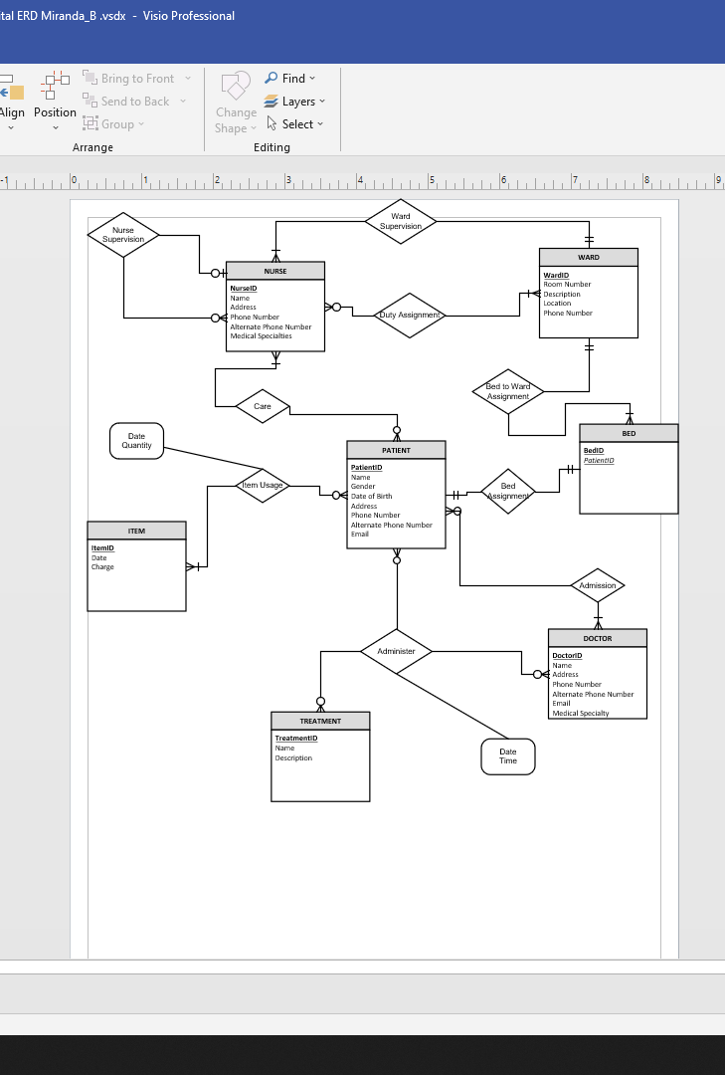ERD MODEL

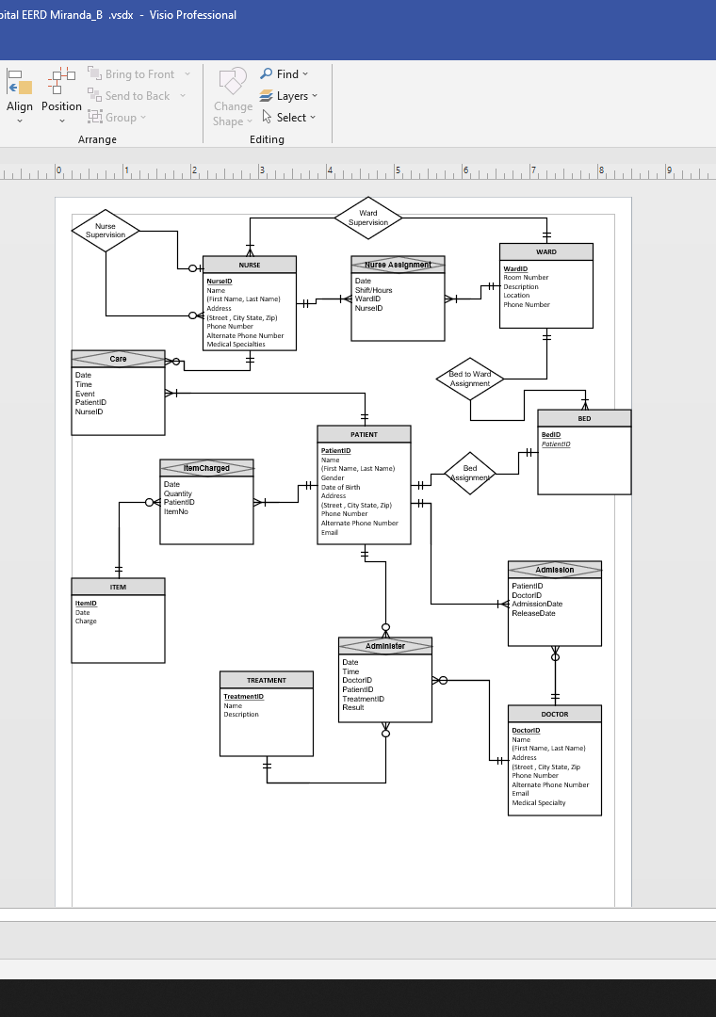EERD MODEL

HOSPITAL RELATIONAL SCHEMA